**Origin of Cicada 3301 logo**

A dead cicada in a scanner.

3301

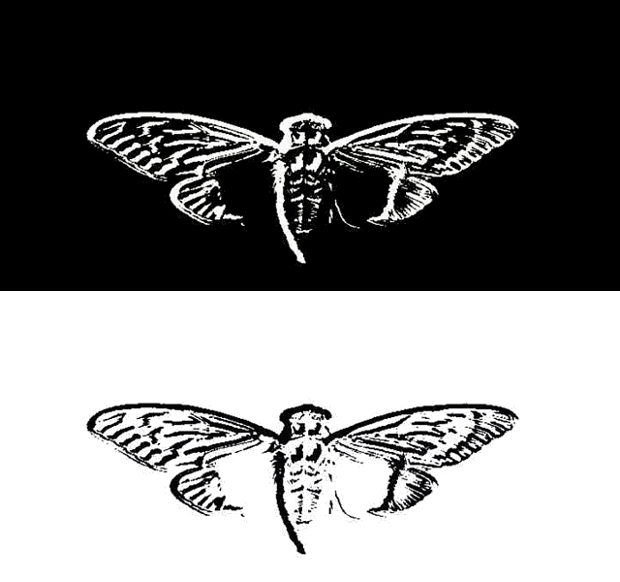

## Log excerpts (more tests coming soon):

[11:14] <iII|out> NiceLurk found a music video around a very similar logo  
[12:12] <NiceLurk> iII|out: video i found, (and lost link to it, and i hate it since lingerie girl in it was superb) used logo from silence of the labs in it  
[12:12] <NiceLurk> that moth with death skull on it  
[12:12] <iII|out> yeah, I thought so  
[12:13] <iII|out> 03:13 <iII|out> a lot of people cite the deaths head moth from other media  
[12:13] <NiceLurk> <http://antibandwagonpropaganda.files.wordpress.com/2011/06/silence_of_the_lambs_expl.jpg>  
[12:13] <NiceLurk> and to be honest  
[12:13] <NiceLurk>  i think initial thought of 3301 when making thair logo was to resemble silence of the lambs  
[12:14] <NiceLurk> <http://2.bp.blogspot.com/-D2C7ZqSV0w0/UDvQt3PGnFI/AAAAAAAAALk/JJFZDrCzor8/s1600/silence_of_the_lambs_ver2.jpg>  
[12:14] <NiceLurk> pshhh dont tell kinds stuff  
[12:14] <NiceLurk> i havent investigated it fully yet but, have you seen guy talking about 3301 logo in cicadamania?  
[12:15] <NiceLurk> he is saying that diferent veins in our logo wings mean that cicada winds on 3301l ogo are collage  
[12:15] <NiceLurk> myaybe even not taken from cicada at all  
[12:16] <NiceLurk> they almost fit silence of lambs windg more than typical cicada wings  
[12:16] <NiceLurk> since anal lobe is missiong on our logo  
[12:16] <iII|out> I hadn't seen that yet  
[12:16] <iII|out> cicadamania?  
[12:16] <NiceLurk> <http://www.cicadamania.com/cicadas/cicada-3301-logo/>  
[12:17] <iII|out> interesting  
[12:18] <NiceLurk> <http://darkroom.baltimoresun.com/wp-content/uploads/2013/04/00252082_H270977.jpg>  
[12:18] <NiceLurk> <http://assets.nydailynews.com/polopoly_fs/1.1335483!/img/httpImage/image.jpg_gen/derivatives/landscape_635/cicadas5n-5-web.jpg>  
[12:18] <NiceLurk> real cicadas have vains on both wings prety much same  
[12:18] <NiceLurk> our doesnt  
[12:19] <NiceLurk> i was playing with thought if maybe one wing is from 13 year and second from 17 year spiece  
[12:19] <iII|out> I wonder what they use  
[12:19] <iII|out> It got suggested last year that it's from a species drawing of one  
[12:20] <iII|out> that would explain some innacuracies  
[12:20] <NiceLurk> those two jpgs i posted are from 17 i think  
[12:20] <NiceLurk> yeah i also heard it is from some old book, but no proof have ben shown  
[12:21] <NiceLurk> but as guy on cicada mania sugested, it can also be emboss filter, and it was made from photo  
[12:21] <NiceLurk> and to he is riht,, it does look more than emboss filter in PS  than drawind  
[12:21] <NiceLurk> <http://www.tannerhelland.com/wp-content/uploads/2009/05/castle_emboss.jpg>  
[12:21] <NiceLurk> and then pasterize on only 2 colors  
[12:22] <iII|out> yeah, but it could be an embossed drawing as well

## Death moth from silnce of the lambs

[15:31] <amone> are you the voice inside your head?  
[15:32] <suomynona> <http://pastebin.com/XP1v2qEu>  
[15:32] <TaiiwoBot> ^ THE MASTER Gutei made a practice of raising his finger whenever he  explained a  - Pastebin.com ^  
[15:32] <NiceLurk> does anybody else think that cicadas logo was inspired by posted for movie for silence of the lambs?  
[15:32] <NiceLurk> <http://slightlywarped.com/crapfactory/subliminal/images/silenc15.jpg>  
[15:32] <TaiiwoBot> ^ <http://tinyurl.com/lnp7bmv> ^  
[15:32] <NiceLurk> this one  
[15:33] <NiceLurk> kind of like shhh, dont tell